**1.Title: Online Recruitment System**

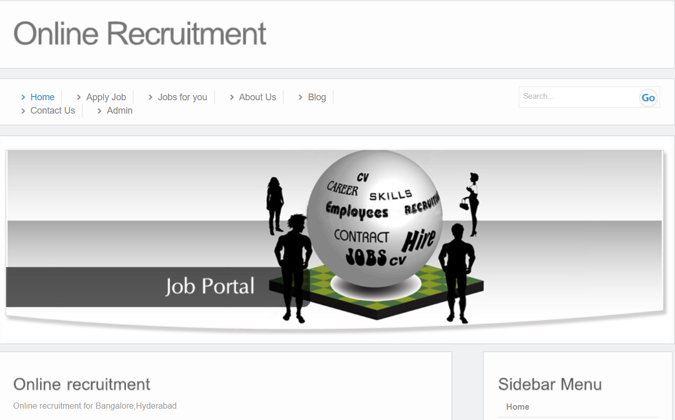

**2.Project Statement:**

The project aims to develop a user-friendly web application that facilitates the

Selection of Job according to the qualification. Graduate is the one who is looking for a job in the same organization who can be either a fresher or an experienced.

Employer is a resource of the organization who specifies there requirements. From each department only one authorized person acts as an employer.

Administrator is also a resource of the organization from HR department. He/she acts as a mediator between the employer and the graduate

**Outcomes:**

Graduate gives the complete details about his/her Personal, Educational and Skills which can be updated accordingly until a valid period of three months.

Whenever there is a vacancy, the employer comes into play by specifying the requirements which are viewed by there registered graduate.

Administrator is responsible to intimate the eligible students for that particular post through e-mail and also updates the employee database according to the instructions given by the employer after the complete process of interview

Enhance patient satisfaction by offering a seamless and user-friendly interface.

1. **Modules to be implemented**
2. User Authentication and Registration
3. Appointment Scheduling Interface
4. Job Availability Management
5. Job Information Management
6. Interview Management
7. Notification System
8. Admin Dashboard
9. **Week-wise module implementation and high-level requirements with output screenshots**

**Milestone 1: Weeks 1-3**

**Module 1: User Authentication and Registration**

* Implement user registration functionality.
* Develop user login mechanism.
* Integrate email verification and password reset features.
* Output screenshot:

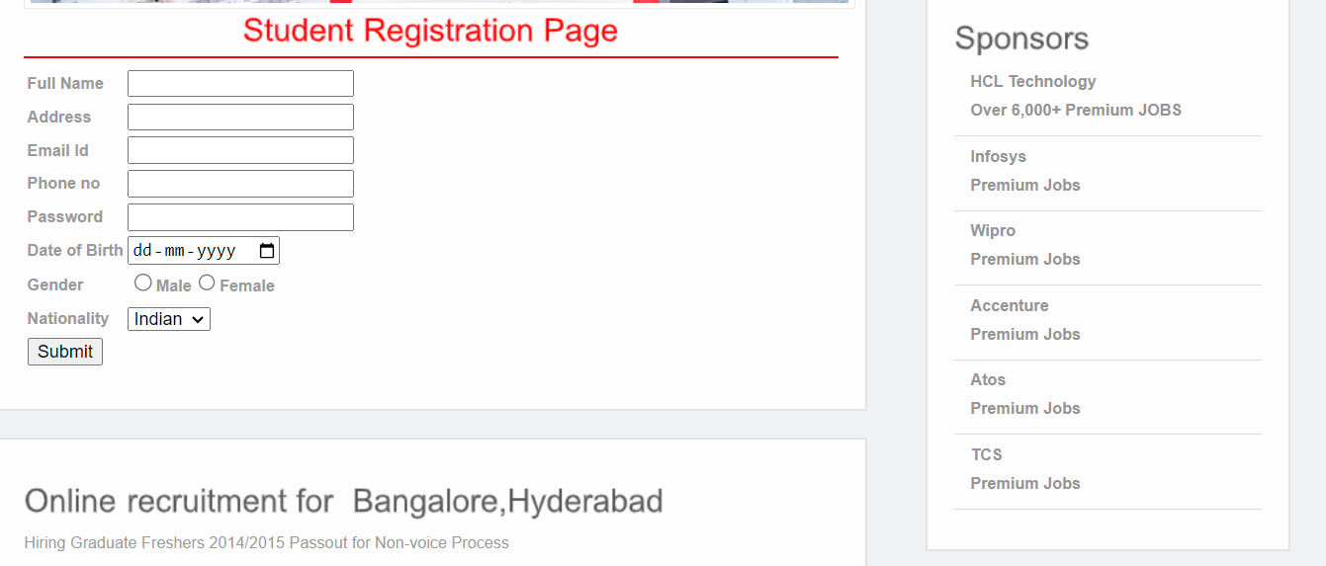

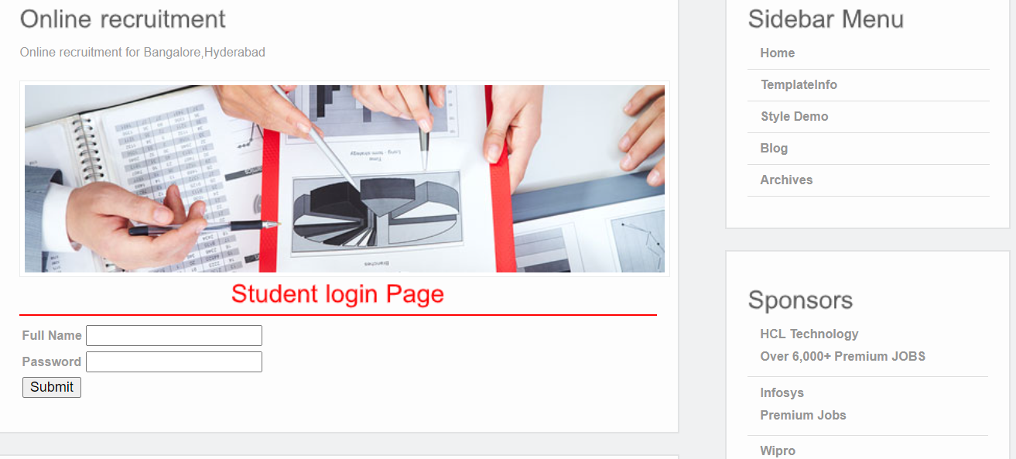

**Module 2: Job Availability Management**

* Design database schema for storing Job availability information.
* Develop an interface for Job seekers to set their availability.
* Implement backend functionality to manage and update Job availability.
* Output screenshot

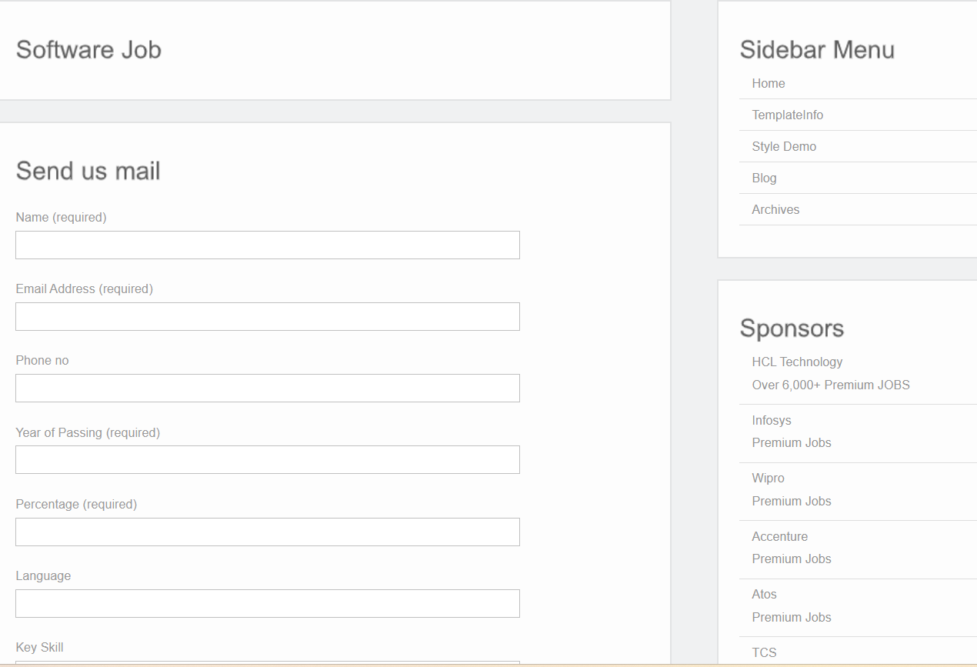

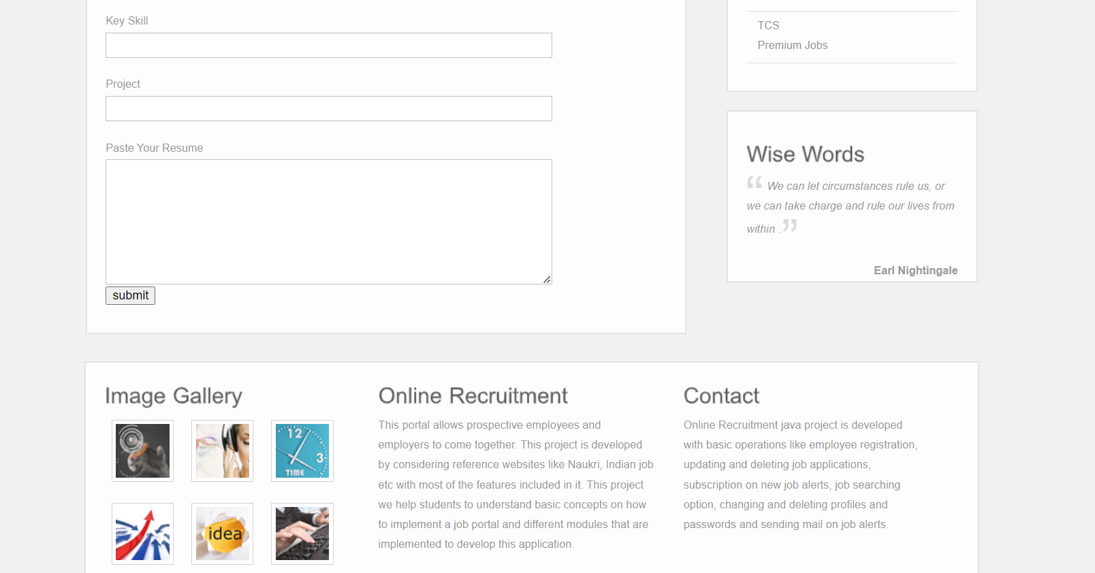

**Milestone 2: Weeks 4-5**

**Module 3: Appointment Scheduling Interface**

* Design and develop the interface for appointment scheduling.
* Implement functionality for users to select Job, preferred time slots, and reasons for the appointment.
* Integrate the scheduling interface with the backend for storing appointment details.
* Output screenshot

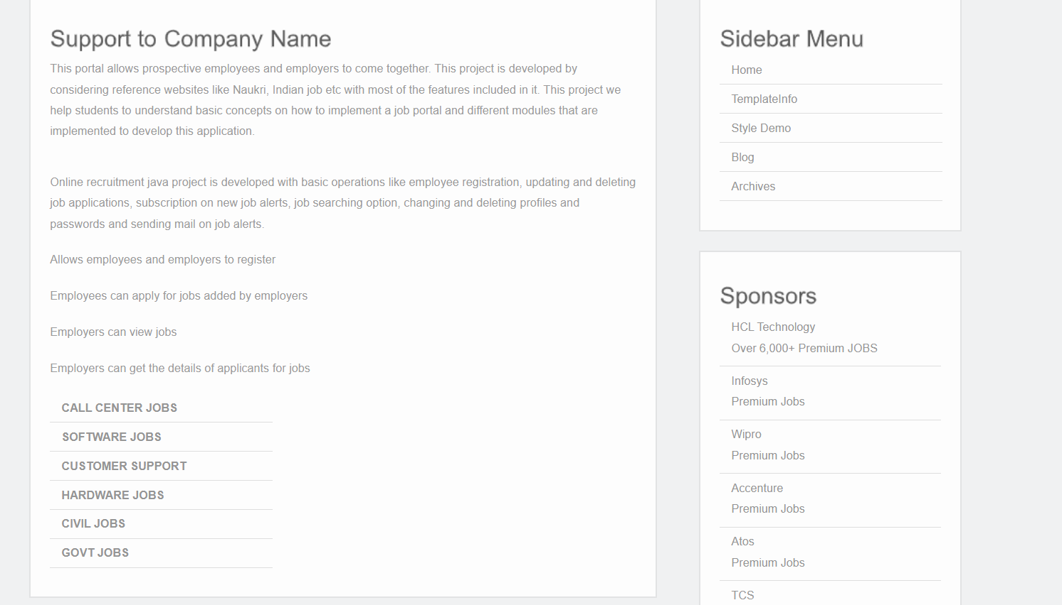

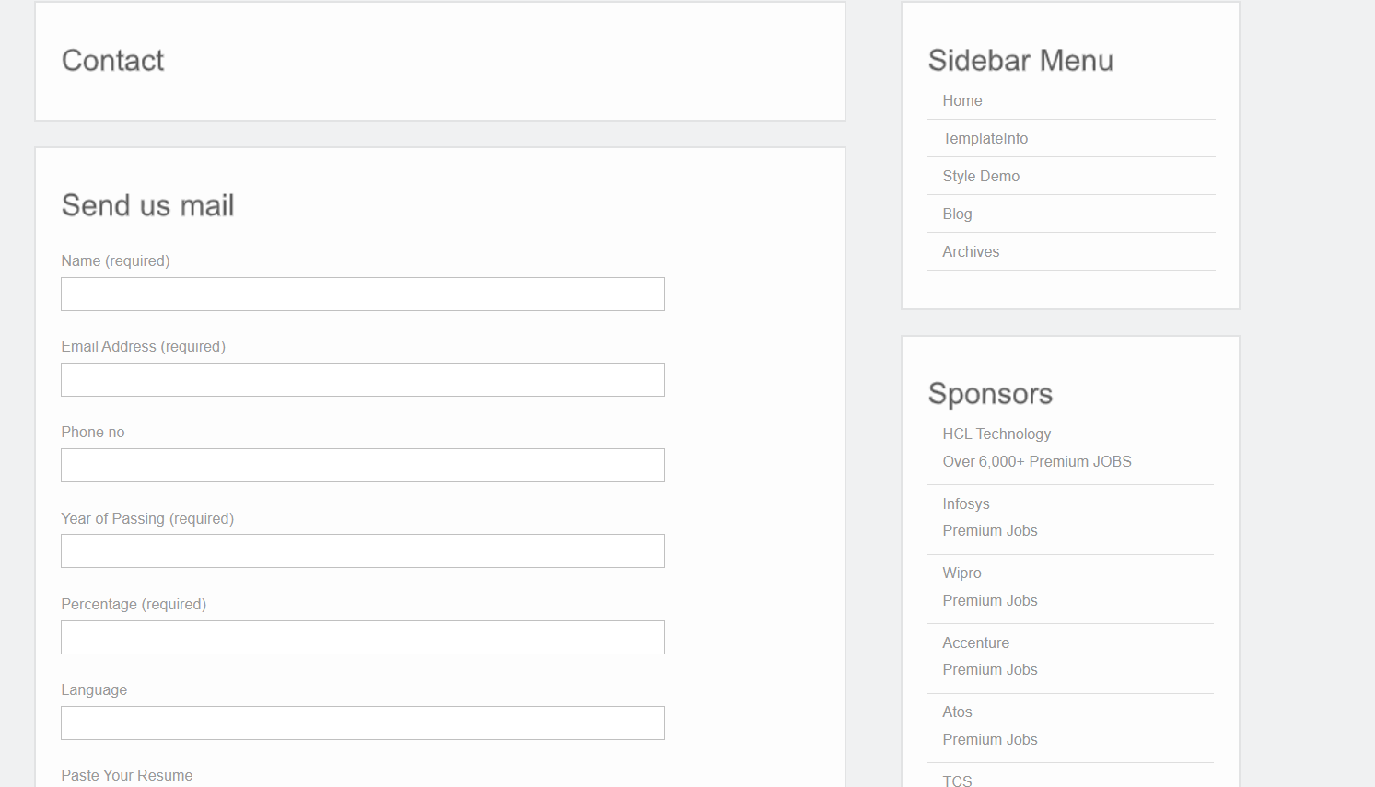

**Milestone 3: Weeks 6-7**

**Module 4: Appointment Management**

* Design database schema for storing appointment details.
* Implement backend functionality for scheduling appointments and preventing conflicts.
* Develop an interface for Job and Job seekers to view and manage appointments.
* Output Screenshot:

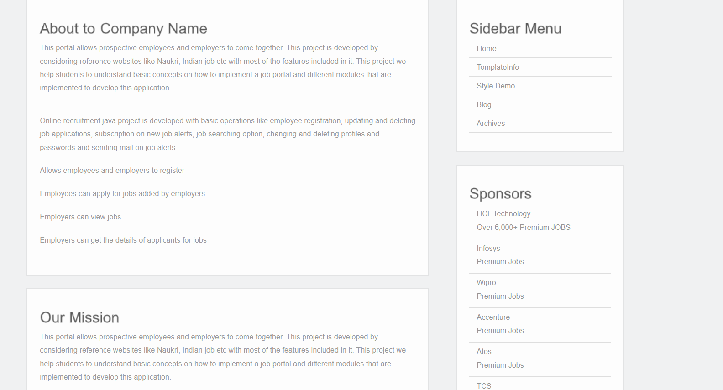

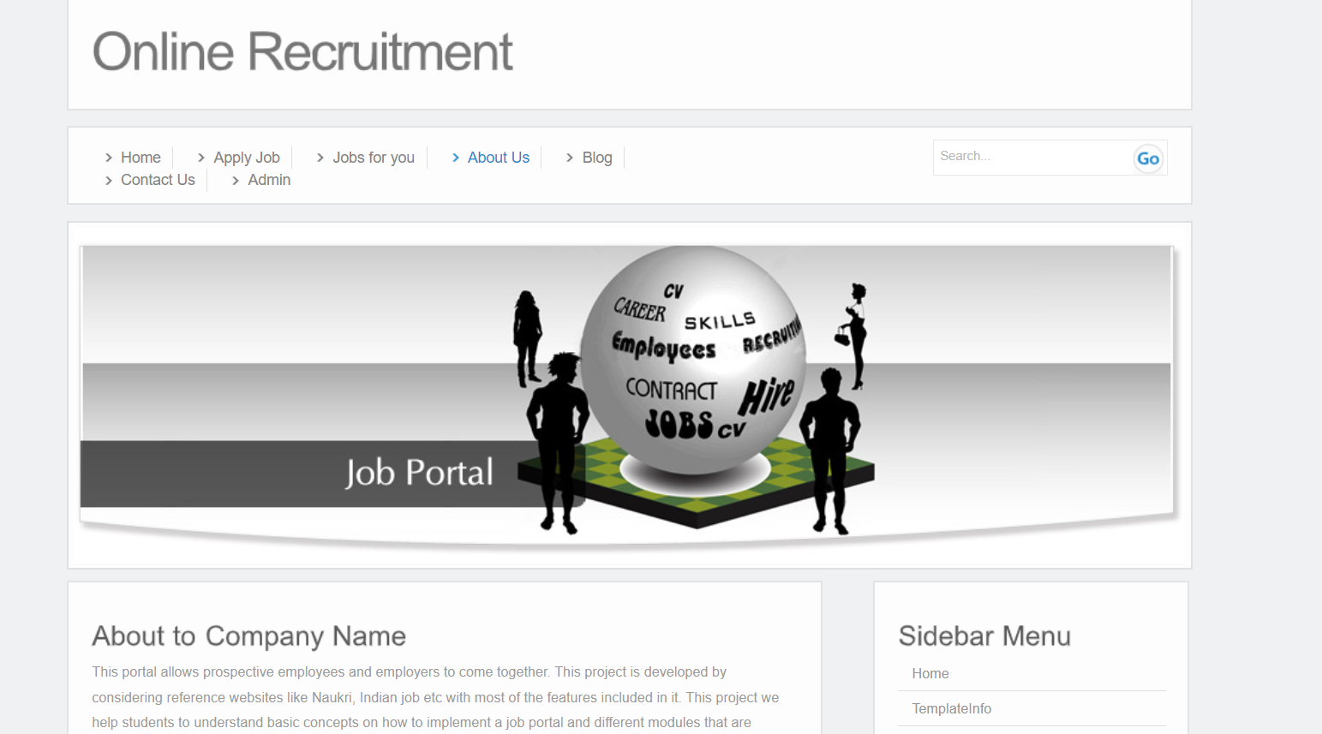

**Milestone 4: Weeks 8-10**

**Module 5: Job Information Management**

* Design database schema for storing patient information securely.
* Develop functionality for Job seekers to provide and update their information.
* Implement backend logic for accessing and managing student information securely.
* Output Screenshot:

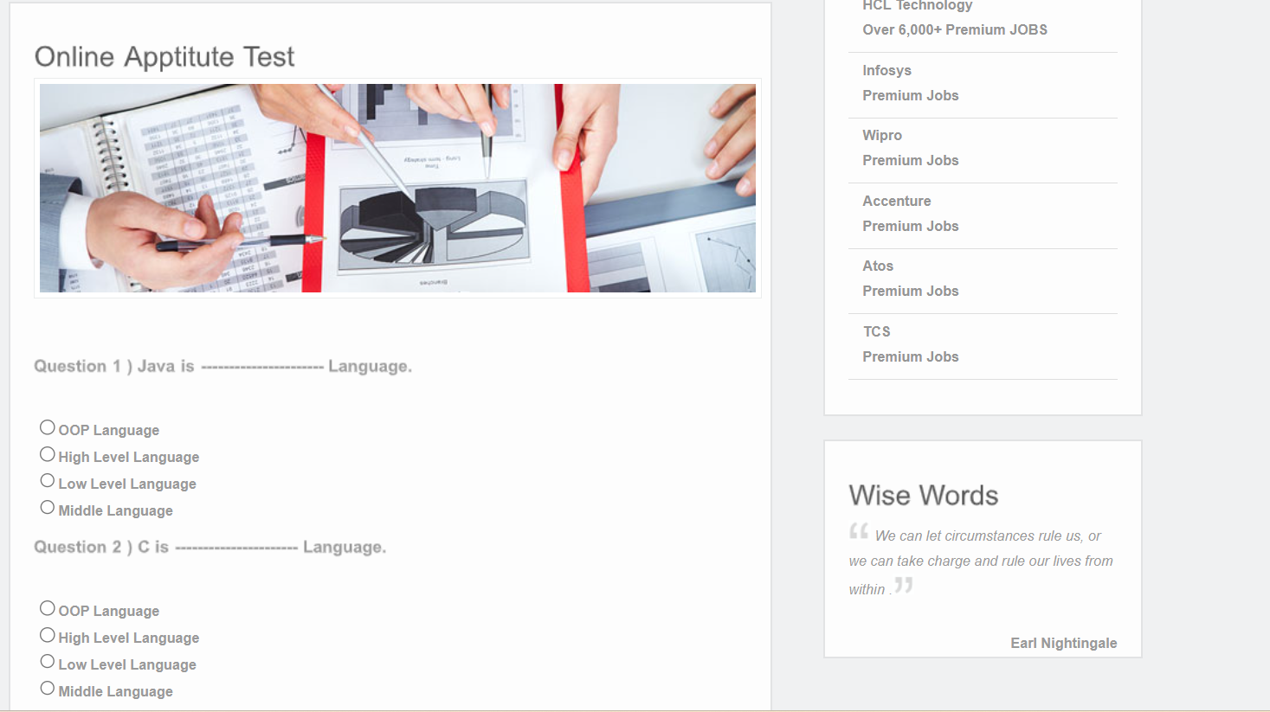

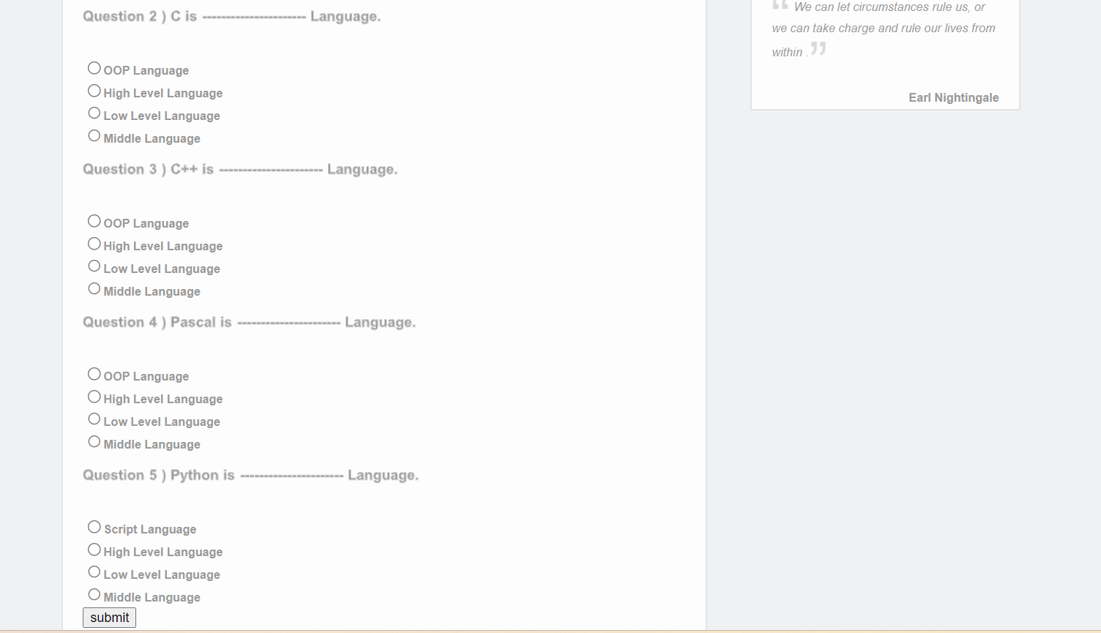

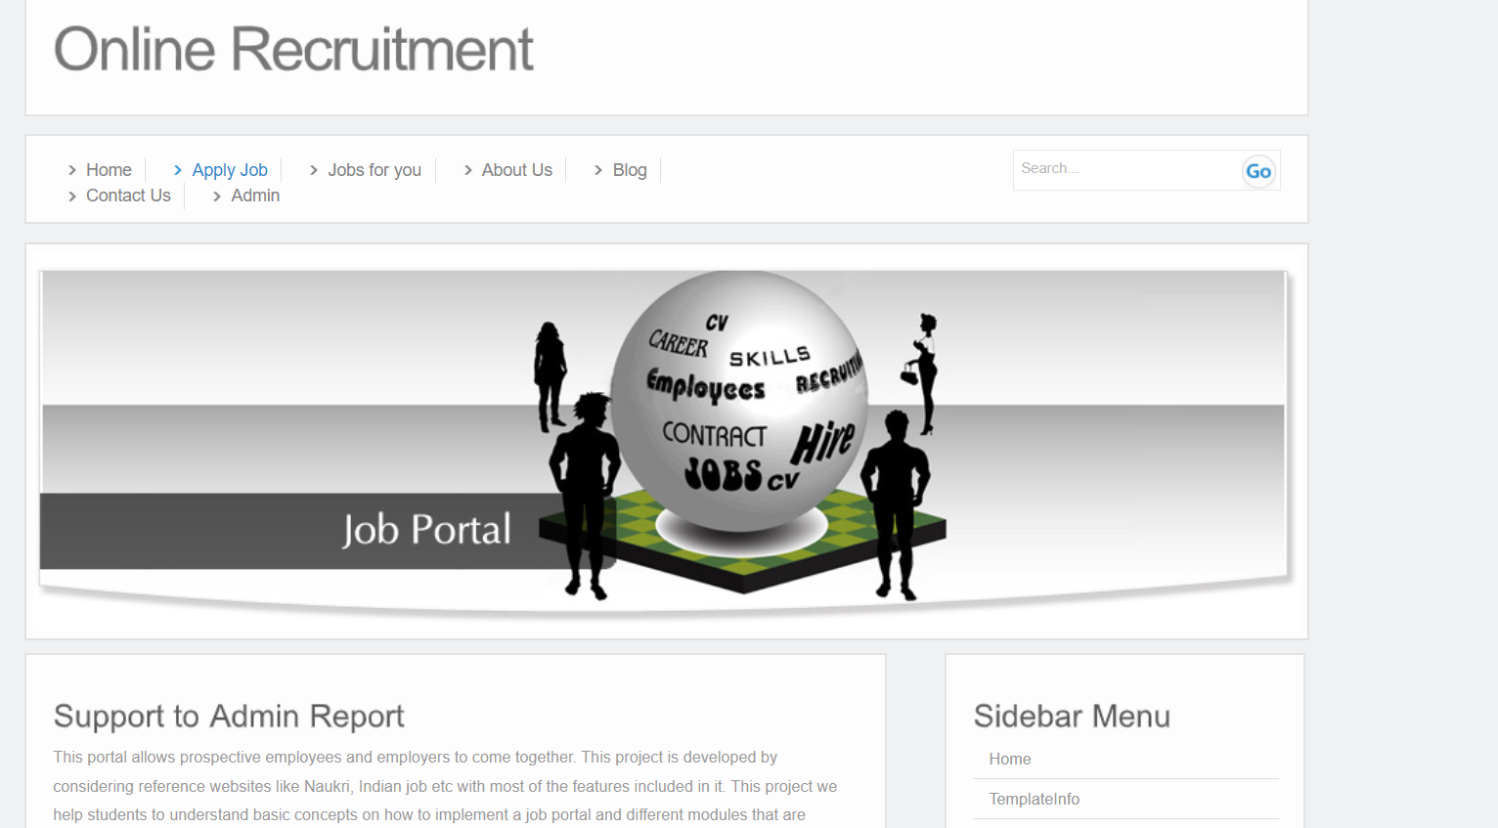

**Module 6: Notification System**

* Integrate email and/or SMS notification services.
* Develop triggers and notifications for appointment reminders, new bookings, and cancellations.
* Implement a system for handling and tracking notifications.
* Output screenshot:

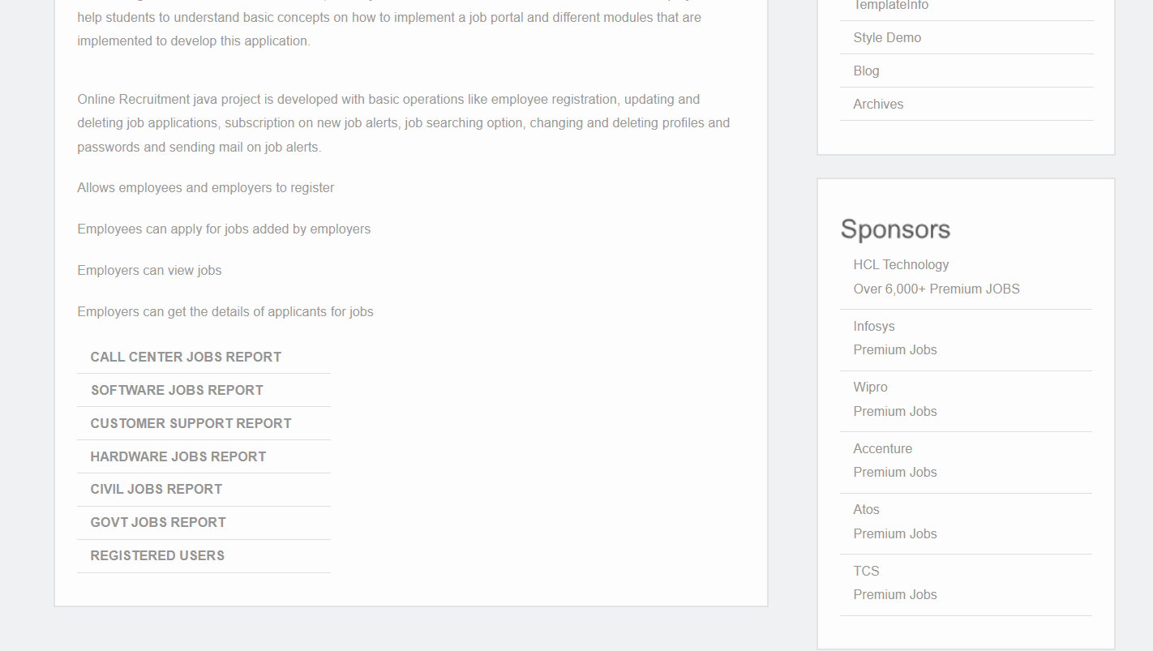

**Module 7: Admin Dashboard**

* Design the layout and functionality of the admin dashboard.
* Implement user management features for admins to add, edit, and delete users.
* Develop modules for managing Job, appointments, and patient information.
* Output Screenshot:





**Evaluation Criteria:**

**Milestone 1 Evaluation (Week 3):**

* Completion of user authentication and registration.
* Successful implementation of Job availability management functionalities.

**Milestone 2 Evaluation (Week 5):**

* Appointment scheduling interface is fully developed and integrated with the backend.

**Milestone 3 Evaluation (Week 7):**

* Appointment management system is operational, allowing for scheduling and viewing appointments.

**Milestone 4 Evaluation (Week 10):**

* Patient information management, notification system, and admin dashboard are fully implemented and functional.

1. Design diagrams

Class Diagram: Entity classes

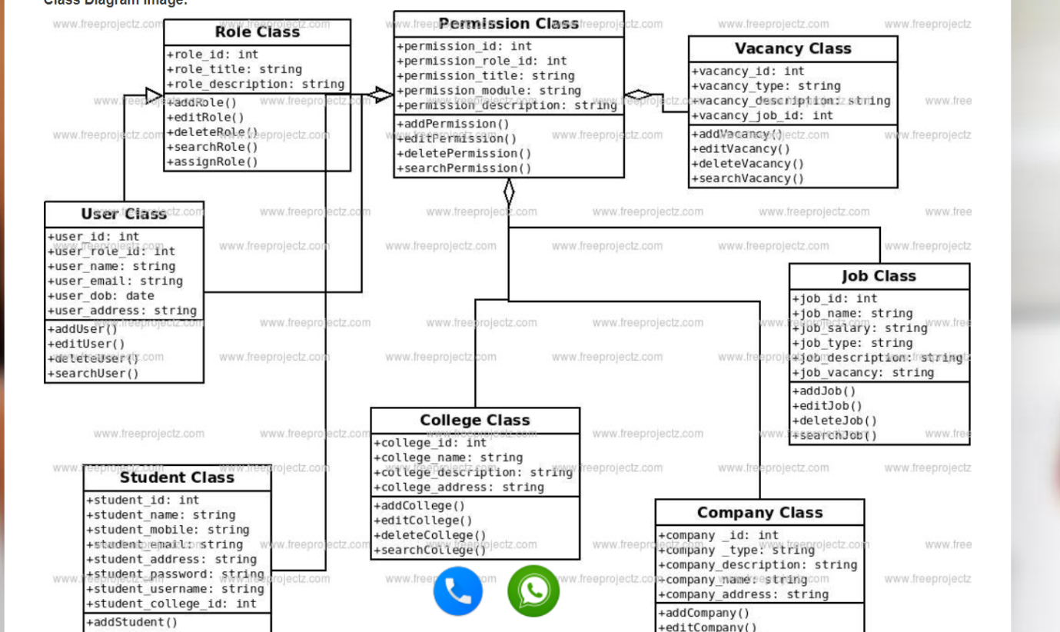

**Output Screenshots:**

1. Dashboard

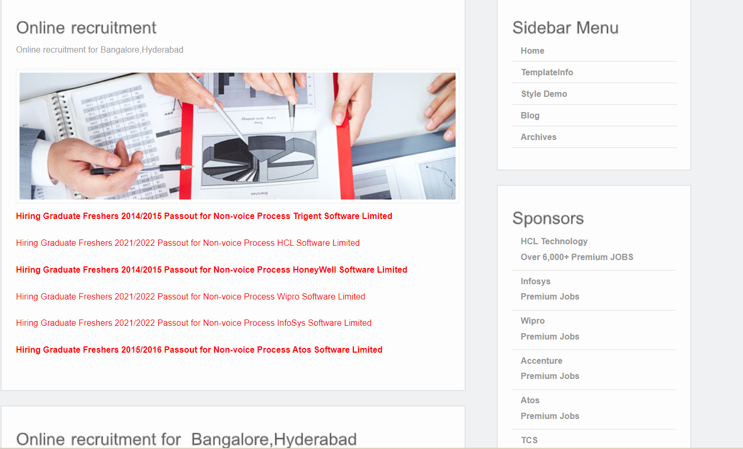

2. Admin Dashboard

